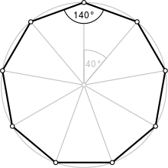The fitness evaluation can be easily achieved by calculating the interior angle of each set of 3 vertices. By drawing a triangle, here…

We can use the given formula to calculate each interior angle.



Any regular polygon has the same interior angles at each vertices and the same length at each side. Let $total= \sum{γ_{i}}$.

We can calculate fitness based on these 2 factors. The best fit polygon would have a fitness score of 0. A regular decagon has an interior angle sum of 1440 degrees. Then $angelFitness = 1440-total$. Ideally we would check the edges for matching length as well.

Let $edgeFitness=\sum{\left|\left(length_{i}-length_{i+1}\right)\right|}+ \left|length_{10}-length_{1}\right|$, then we should be able to obtain a value that could be added to $angelFitness$ to give the ultimate index of fitness for each spawn within a given generation. Thus, the final fitness value for each chromosome in a given generation would be $fitness=angelFitness+edgeFitness$.